

## A

**Project Report On**

**“Insurance Management System”**

**At**

### RihaSoft Ltd. , Jalgaon.

***Submitted in the partial Fulfillment of the Requirements***

***Of***

### BACHALOR OF COMPUTER APPLICATION

**Submitted By**

## MULMULE NANDINI RAJARAM

### PRN NO.:- 334411190106

**Email ID:** [nandini9tweety@gmail.com](mailto:nandini9tweety@gmail.com)

[**www.mjcollege.kces.in**](http://www.mjcollege.kces.in/)

**K.C.E Society’s**

**Moolji Jaitha College , Jalgaon.**

"**An Autonomous College Affiliated to K.B.C. North Maharashtra University, Jalgaon."**

**NAAC Accredited ‘A’ Grade (with CGPA 3.63) UGC honored ‘College of Excellence’**

**Academic Year - 2021-22 Guided By**

**Prof. H.D.Deshmukh**

***CERTIFICATE***

This is to certify the **MULMULE NANDINI RAJARAM** student of

T.Y.B.C.A. SEM-VI of M .J.College(Autonomous),Jalgaon[Project work] has details information on ‘**Insurance Management System**. She is Hard Working and sincere, and we wish her every success in future.

She has developed the project in partial fulfillment of the requirement for the TYBCA [Computer Application] under our supervision and guidance during the year 2021-2022.

Date: / /2021-22 Place: Jalgaon

Manager

K.C.E. Society’s

# MOOLJI JAITHA COLLEGE, JALGAON

"**An Autonomous College Affiliated to K.B.C. North Maharashtra University, Jalgaon."**

NAAC Re-accredited “A” Grade (with CGPA 3.63) UGC honored “College of Excellence”ISO

9001:2008 Certified

Faculty of Science

Professional Management

~~~Certificate~~~

This is to certify that **NANDINI RAJARAM MULMULE** is a confide student of M. J. College, Jalgaon and She has completed the Project, titled **Insurance Management System** guidance in partial fulfillment of the requirement for the degree of “**Bachelor of Computer Application**” for the year 2021-2022 of KBC North Maharashtra University, Jalgaon*.*

##### Project Guide HOD

**Examiner Examiner**

**Acknowledgement**

The satisfaction that accompanies that the successful completion of any task would be incomplete without the mention of people whose ceaseless cooperation made it possible, whose constant guidance and encouragement crown all efforts with success.

We are grateful to our project guide Prof. H.D.Deshmukh for the guidance, inspiration and constructive suggestions that helpful to us in the preparation of this project.

I acknowledge most sincerely and respectfully **CA A. N. Arsiwala**,Incharge of Management Faculty, **Moolji Jaitha College (Autonomous), Jalgaon.**

Finally, I appreciate my colleagues and friends who kindly offered their suggestions, comments and criticism for improvement of this report

**NANDINI RAJARAM MULMULE** **(T.Y.B.C.A)**

**Index**

|  |  |
| --- | --- |
| **Sr.** | **Chapter name** |
| 1. | Introduction |
| 2. | Needs |
| 3. | Objective |
| 4. | Scope of project |
| 5. | Technology proposed for project |
| 6. | Feasibility Study |
| 7. | Case Tools |
| 8. | Testing tools |
| 9. | Onscreen Views |
| 10. | Limitation |
| 11. | Conclusion |
| 12. | User manPual |
| 13. | References |

1. **Introduction**

Nowadays, insurance have been widely accepted by the public . There are many type of Insurance such as car insurance, accident insurance, property insurance, Life insurance and others. I f you pick 10 people to be survey and ask whether they are covered by insurance , I am sure most of them give a positive answer.

The users will benefit from IMS are the insurance agent from various insurance companies such as AIA Insurance , Prudential Insurance,ING Insurance,Kurnia Insurance and others .For this project ,AIA insurance company will be my reference organization .The insurance packages offers by AIA will be integrated into the IMS. The insurance rate calculation is based on the rate given by AIA.Other insurance packages from other companies can also integrate into the system. The IMS administrator can set the rate into IMS.

## NEED

**Needs:**

Admin finds it very easy way to obtain the customer, supplier and Bill information.

* User friendly.
* Admin can get the Timely Information from the database without any delay regarding the query.
* This reduces the delay of response.
* System provides Reports to admin for making quick decisions.

## OBJECTIVES

**Objectives of project:**

The main benefits of this software will be paper saving and most important one: **Time saving**. Earlier these records were maintained on a paper on daily basis but now these can be easily done using this software.

All the transactions can carried out (with details) in this software. This software can be installed on any Operating System. This software does not require special templates, frames, coding, or server-side technology.

1. **Volume Handling: -** It is possible to keep the sales & purchase records on papers but since sales & purchases are daily transactions it will requires too large bundle of papers which needs large storage area & than also the papers get older soon as the time passes.

The computer being electronic machine saves each & every data for long period as we desire & protects it from damage. It has large memory capacity, which can store more than sufficient amount of data.

1. **Reliability**: - As the data is saved one can add, modify & delete data as & when required. Processing is done by the computers are accurate provided that user is accurate & the reports generated are appropriate, attractive & more readable so users may rely on the computer

.

1. **Speed/Communication**: - Being electronic device the computer processing is faster and that increases the speed of work and within few seconds the records of

previous years can also be processed. It affects the communication & decision making also.

1. **Security: -** As the data stored & doesn’t get damaged unless the physical device is not proper. The part of the data can be viewed & can be taken on printers as & when required. One can validate the data while entering. The storage of previous records is possible by secondary device & provides future retrieval.
2. **Complete Control: -** One can get the proper massages & accordingly decide regarding the future plans & hence the complete control is left to computer.
3. **Cost**: - The decision at the right time makes it possible to keep the stock in control & thus provide right investment.

## SCOPE OF PROJECT

* The system is convenient and flexible to be used. It saves their time, efforts, money and resources.
* User Friendliness is provided in the application with various controls provided by system Rich User Interface.
* The user information files can be stored in centralized database which can be maintained by the system.
* Purchasing insurance online is convenient and fast. With click of a mouse customers can buy any policy from any corner of the world at any point of time.
* This system maintains profile management of all policy holders. This system providing interface to customer that helps to him to know his policy details.
* Payment process also like ecommerce transaction. Customers can pay their policies through online. The payment processes is hassle-free and customer can complete a transaction at a much lesser time.
* Since the customer buys directly from the insurance company, the agent’s margin (or commissions) is saved. Also, the entire process is carried in the virtual world and is paperless, reducing the costs further.
* This system provides information about new policies or existing polices through online.
* All communication happens via email, which are faster and more reliable than courier or post.

## TECHNOLOGY PROPOSED FOR PROJECT

#### HARDWARE AND SOFTWARE REQUIREMENT

A major element in building system is selection of compatible hardware & software. Hardware selection they begin with requirements analysis following by a request for proposal, evaluation & validation, post installation review.

While selecting the software various criteria is considered such as reliability (gives consistent results), functionality (function to standards), capacity (satisfies volume requirements), flexibility (adapts to changing needs), usability (user friendly), security (to prevent unauthorized access), performance (capacity to deliver as expected), serviceability (good documentation), minimal cost (affordable for intended application).

#### Software Requirement:

* 1. Operating System-widows 10
  2. Apache Netbeans IDE
  3. .JDK,
  4. MYSQL Workbench

#### Hardware Requirement:

1. I3
2. Minimum 2GB RAM.
3. Maximum 500 GB HDD.
4. Input Devices: Keyboard, Mouse.

## 6. FEASIBILITY STUDY

At the time of the development we have gone through the following phases:

#### Recognition of need (Requirement specification):

It refers to the organization’s needs, requirements and expectations from the project to be developed. After recognizing the organization’s need, it has been taken in writing and then a rough idea of the system/project has been given to the firm.

##### Feasibility Study:

It is always essential to evaluate the various aspects before we develop the project. Evaluation should always justify the cost and benefits ratio. Economic, social and technical feasibility of project is analyzed.

##### Data Collection:

Here comes an important aspect of project development i.e. data collection. For this to accomplish, we observe registers, bills, invoices and order forms at client’s firm.

##### Data Normalization:

Normalization means allowing only a single value in a table’s row and column intersection. For this, entities are identified from the data collected and normalized tables with appropriate relationship and minimized redundancy are designed.

##### System Design:

This step includes drawing of different diagrams such as DFD and ERD. It includes database design, form design etc.

##### Coding:

It is the most critical stage among all the stages of development. It has taken approximately seven days to complete. It involves giving functioning to data entry forms with the help of action, validation, calculations and linking of different data entry forms.

* 1. **Testing:** It involves testing of the working of the project.

##### Implementation:

This involves deployment of project to client side.

##### User training:

It is one day activity involving training to the user to operate the project

## 7. CASE TOOLS

It is always essential to evaluate the various aspects before we develop a system. Evaluation should always justify the cost and benefits ratio. If it is found that benefits are less as compare to the cost of project, then it is better to avoid going in for computerization.

The key consideration involved in the Feasibility analysis is:

##### Technical Feasibility.

* + 1. **Economical Feasibility.**
    2. **Social Feasibility.**

1. **Technical Feasibility:**

For this project technical feasibility should be studied in two aspects i.e. Hardware feasibility and software feasibility. The system should be easy to update

i.e. if the user wants to made some changes in the system then it should be easy for him to change without disturbing the initial system. It should be develop in such a way that it will easy to operate.

It should be menu driven and provide help features and give message on each option so it should be easy to even novice to operate the package. Few hours training is sufficient to train the operator.

#### Economical feasibility:

Cost benefit analysis gives justification for the computerization. In this the benefits and savings that are expected are comparing with costs. If benefits overweigh cost then only the decision is made to design and implement the system. In our case, computerization results reduction of cost, reduction of staff and reduction and of non-reusable stationary. The computer stationary will replace various types of bills and registers. However the overall effect on the operating

cost is that we get substantial reduction in monthly running cost. Cost will reduce also in terms of reduction in expenses for space and computers required.

#### Social Feasibility:

Operating with records in both situations i.e. in manual system and computerized system is quite different. Manual system is always disliked because of the complications and other hustle involved in maintaining the records. Computerization will be welcomed because of the simplicity in the data entry and fastest and easy way of getting outputs. After computerization it will become the job of single operator with no risk involved in posting and report generation. Speed of the operation will also increase substantially and hence reporting service to patient will be faster. Hence all welcomes computerization.

## Data Flow Diagram (DFD)

* + Data flow diagram is graphical tool which is used to describe and analyzethe movement of data through a system. They focus on the data flowing into the system, between processes and in & out of data stores.
  + DFD is a graphical technique that detects information flow and transformation that are applied as data move from input and output.
  + DFD is a central tool and the basis from which other components are developed.
  + DFD provides mechanism for a final modeling as well as information flow modeling.
  + DFD has very simple notation which are easily understood by the users & those who involved in the system.

**Symbol used for DFD**

**Symbol Meaning**

External Entity as source Destination.

Process or Function.

Indicates the direction of data flow File Storage i.e. data is

Stored for use by one or more.

## Data Flow Diagram

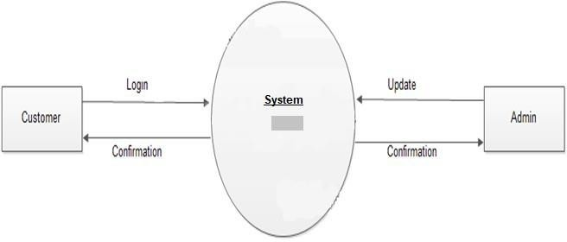

**Entity Relationship Diagram**

An ER-Diagram can express the overall logical structure of a database graphically. The Entity Relationship Diagram enable a software engineer to fully specify the data objects that are input from a system, the attributes that define the properties of these objects and the relationship between the objects.

* The ER model is one of the several semantic data models; the semantic aspect of the model lies in the attempt to represent meaning of the data.
* The ER model is extremely useful in mapping the meaning and interaction of real world enterprise into a conceptual schema.
* It is notable point that concept of ERD is totally different from DFD. The ER-Diagram is used to describe the logical organization of data.

There are following four type of relationships diagram between entities given as follows:

1. One to One
2. One to Many
3. Many to One
4. Many to Many

**Symbol used for ERD**

### Symbol Meaning

Entity Attribute

Relationship

Links

## Entity Relationship Diagram

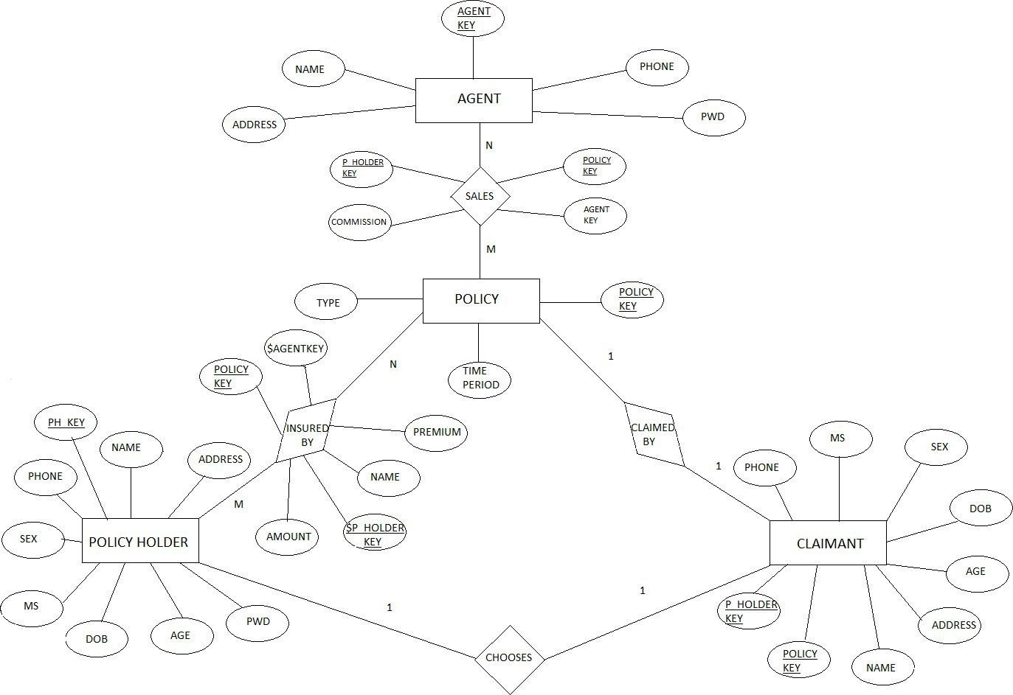

**8. TESTING TOOLS**

Testing is important from the point of view of accurate functioning of the project.

There are many testing measures and tools available to test a project.

Basic tools used to test this project are:

1. Black Box Testing.
2. White Box Testing
3. GUI Testing

## Black Box Testing:

It is a method of software testing that tests the functionality of an application as opposed to its internal structures or workings. Specific knowledge of the application’s code/internal structure and programming language in general is not required. The tester is only aware of what the software is supposed to do, but not how i.e. when he enters a certain input, he gets certain output; without being aware of how the output was produced. Tests cases are build around specifications and requirements, i.e., what the application is supposed to do. It uses external descriptions of the software, including specifications, requirements and designs to derive test cases. These test designer select valid and invalid inputs and determine the correct output. There is knowledge of the test object’s internal structure.

This method of test can be applied to all levels of software testing: Unit, Integration, System and Acceptance. It typically comprises most if not all testing at higher levels, but can also dominate unit testing as well.

## The advantages of this type of testing include:

* + The test is unbiased because the designer and the tester are independent of each other.
  + The tester does not need knowledge of any specific programming languages.
  + The test is done from the point of view of the user, not designer.

## The disadvantages of this type of testing include:

* + The case can be redundant if the software designer has already run a test case.
  + The test cases are difficult to design.

## White Box Testing:

White box testing is a method of testing software that tests internal structures or workings of an application, as opposed to its functionality. In white-box testing an internal perspective of the system, as well as programming skills, are required and used to design the test cases. The tester chooses input to exercise paths through the code and determine the appropriate outputs. While white-box testing can be applied at the unit, integration and system levels of the software testing process, it is usually done at unit level. It can test paths within a unit, paths between units during integration, and between subsystems during a system level test. Though this method of test design can uncover many errors or problems, it might not detect unimplemented parts of the specification or missing requirements.

#### White-Box test design techniques include:

* + Control flow Testing
  + Data flow Testing
  + Branch Testing
  + Path Testing

For a complete software examination, both white box and black box tests are required.

#### Graphical User Interface Testing:

It is the process of testing a product’s graphical user interface to ensure it meets its written specifications. This is normally done through the use of a variety of test cases. It checks only the user friendliness. The creation of the user interface is less time consuming for the user but more complex for the programmer. It must be tested for its sole purpose.

## This test must be carried out to ensure:

* + Windows open properly.
  + All data contents are properly addressable.
  + All the graphical elements are available and displayed. Multiple or incorrect mouse click do not produce side effects

1. **Onscreen Views**

# Login Page

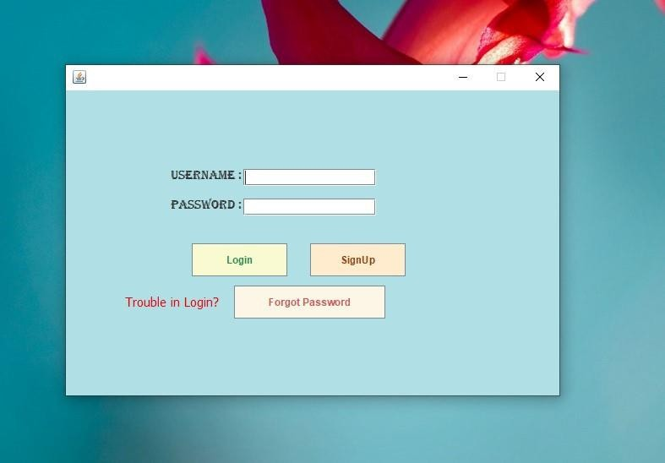

**Signup Page**

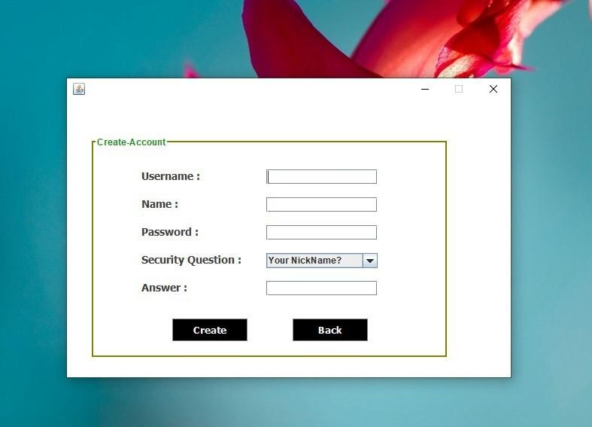

## Forgot Password Page

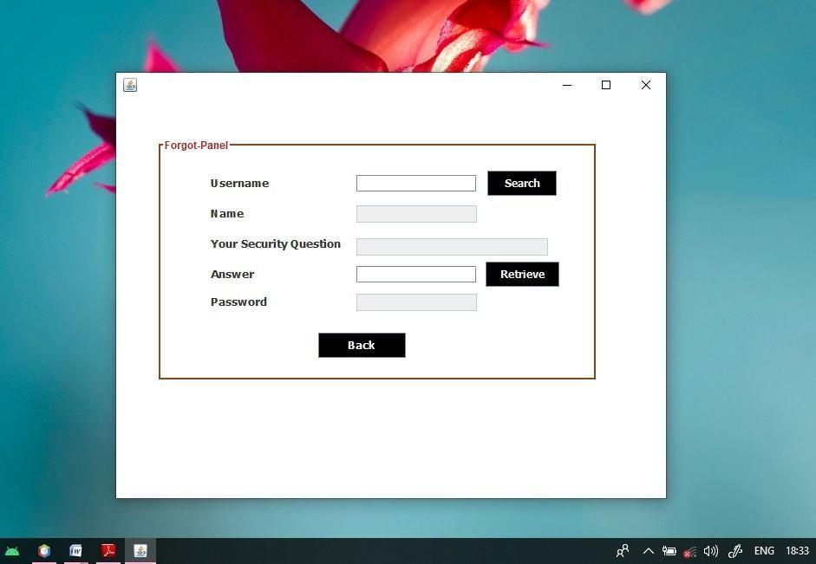

**Loading Page**

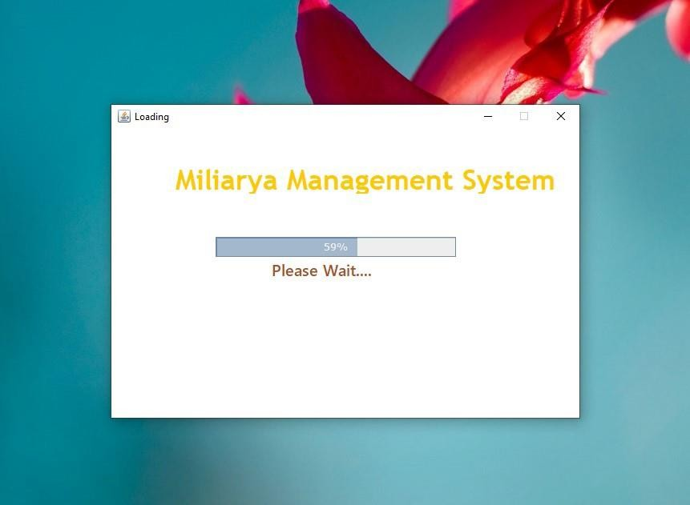

## Main System Page

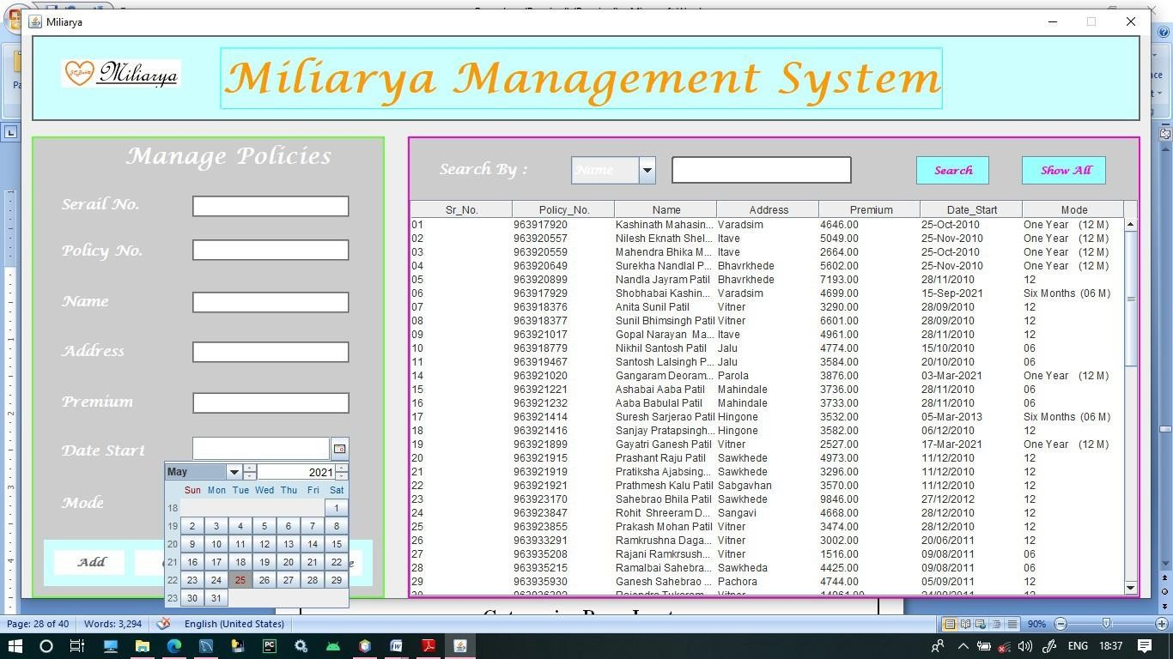

**Add Policies_holder**

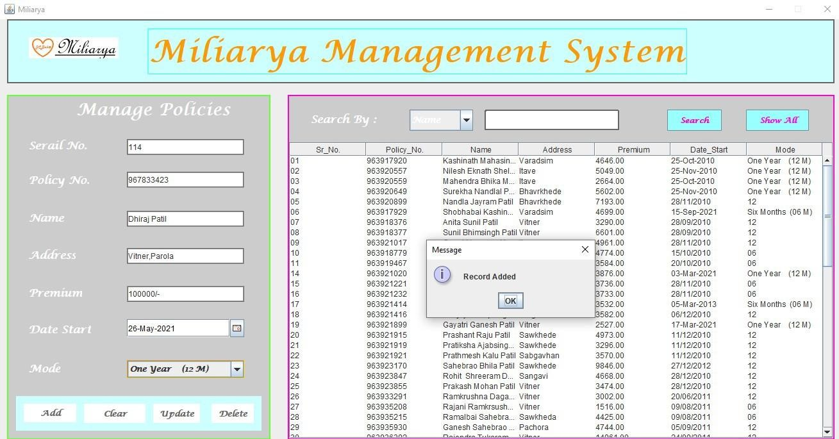

## Clear Data From Textfield

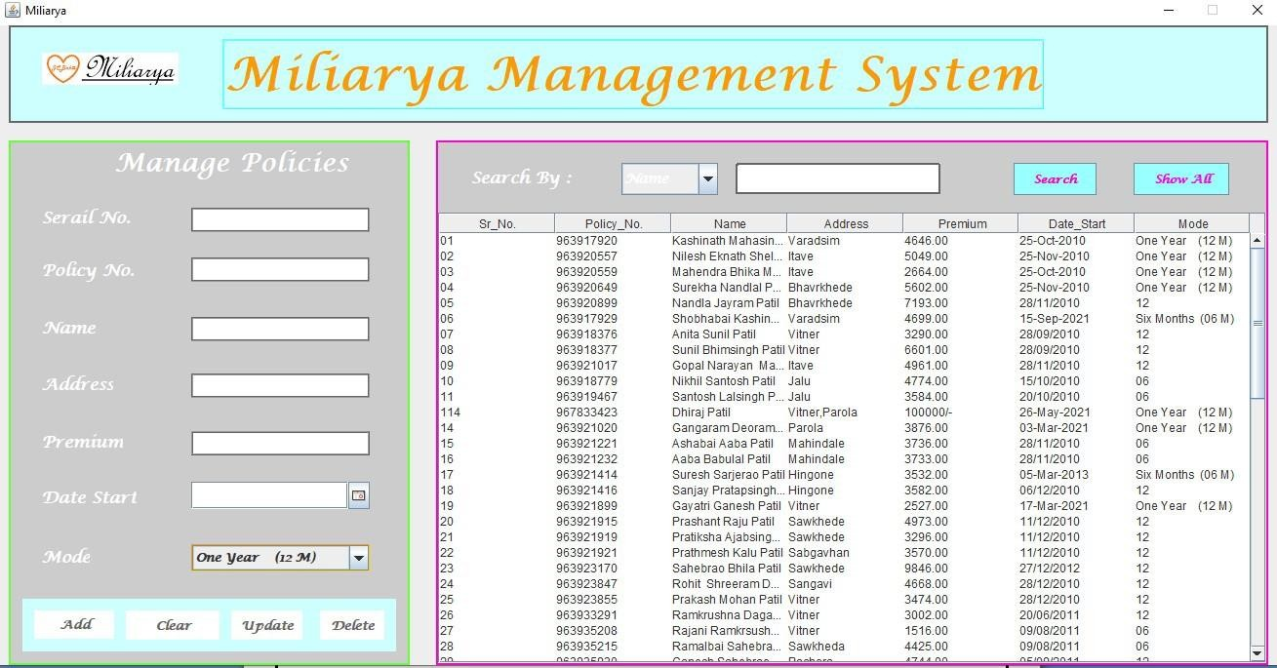

**Update Data - Page**

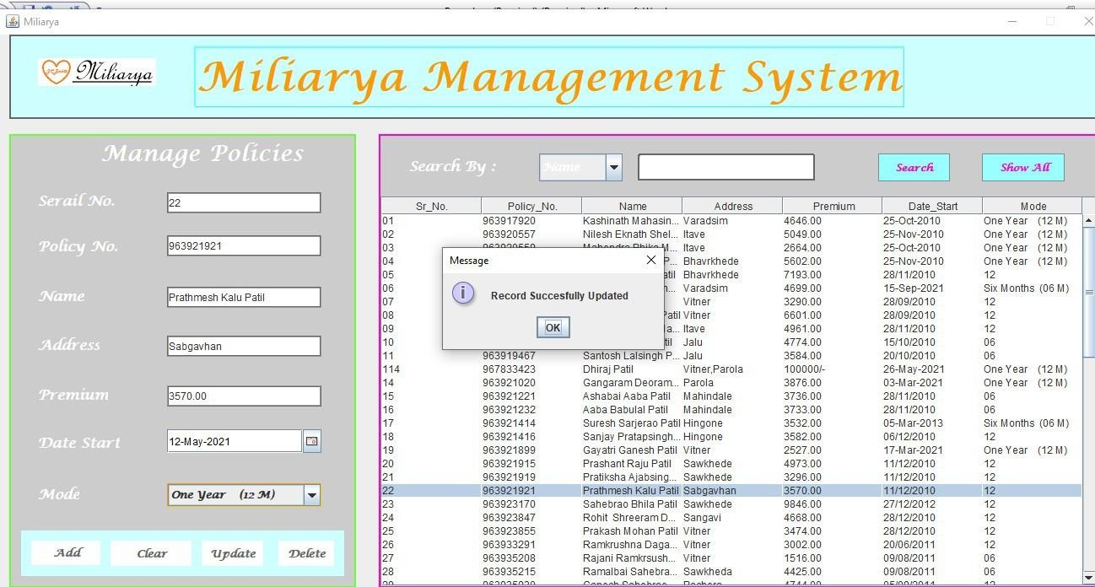

**Delete Policy_holder**

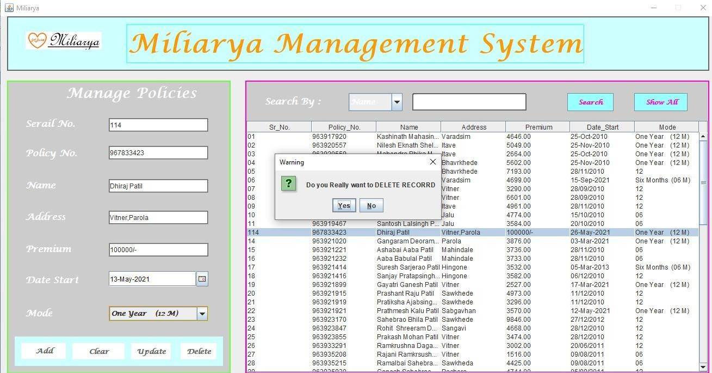

**Search Policy_holder**

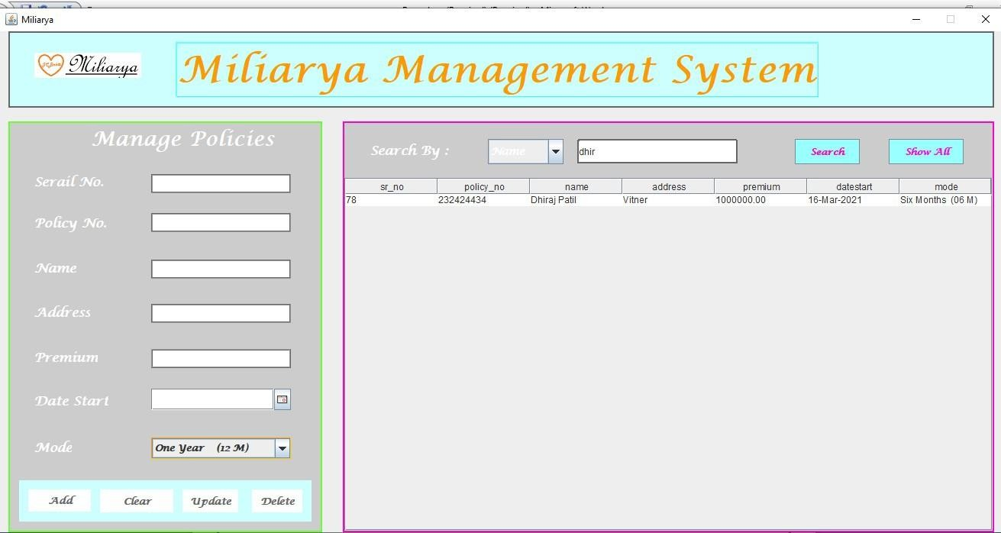

1. **LIMITATION**

The problems faced by the researcher include lack of finance, research materials and time.

Lack of money prevented the researcher from traveling outside Enugu to search for materials.

**Time:** The time allocated to the project work is too short coupled with other academic activities.

**Research materials:** Lack of research materials is another problem that faced the writer.

**Poor response from the respondents:** Many of them fear that their masters will victimize them if they release information’s.

## CONCLUSION

A computerized insurance management system has been developed and the system was tested with sample data.

The system results in regular timely preparations of required outputs. In comparison with manual system the benefits under a computer system are considerable in the saving of man power working hours and Effort.

Provision for addition, updation and deletion of customers is there in the system .It is observed that proper filing system has been adopted for future reference. The entire project runs on windows environments.

The system can be used to make better management described at appropriate time. The user gets amount and timely information system.

The system is-

* **User Friendly**- The system is totally user friendly & easy to operate & understand.
* **Duplicity-** As data is completely normalized, so that no duplicate entries exists
* **Menu driven**- This system is totally menu driven for the best result.

## USER MANUAL



**USER REQUIREMENTS:**

Every user interacts with the system with some needs and requirement such as:-

1. Basic knowledge of computer should be required.
2. User should know basic knowledge about the computerized Courier Services

i.e. which are the modules of the computerized system, what is the function of each module.

1. Comprehensive information accessing and retrieving so as to provide valuable report and figures.
2. Data security and priority is not to be ignored.
3. At the time of generating the reports, where the corresponding reports are to be set in the computerized system.
4. Every user must know the function of each Master entry, Transaction entry and Reports.
5. The format, field within a format, data types, what type of data is to be entered, what is the maximum size of each entry module. The user must know each thing.
6. In short, operating environment about the computerized “Insurance Management System” must be familiar to the user.
7. Every Text Box should be filled with Data .If data is not available put at list ‘.’(DOT) for character, as well as for numeric data’0’ (ZERO) should be placed.

## REFERENCES

#### Books:

* 1. Core Java Volume I- Fundamentals
  2. Effective Java
  3. Java: A Beginner’s Guide
  4. Head First Java
  5. Java: The Complete Reference
  6. TDD for JAVA

#### Websites:

* + 1. [www.tutorialspoint.com](http://www.tutorialspoint.com/)
    2. [www.w3schools.com](http://www.w3schools.com/)
    3. [www.dotnettricks.com](http://www.dotnettricks.com/)
    4. [www.tutorialsteacher.com](http://www.tutorialsteacher.com/)
    5. aspnettutorials.com